**1.wireless sensing foundation**

**Functions of wireless blocks:**



This block is to set the group ID of the wireless communication, and can only listen to a group ID at any time.

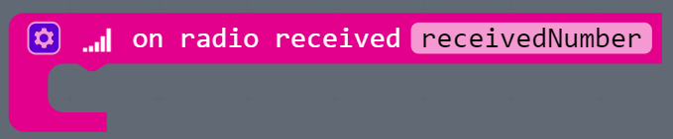

This block is to read the received digital packets. When the packet is received wirelessly, you can use this block.

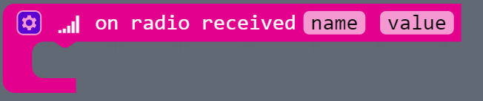

This block is to read the received name of variable and value of name. When the packet is received wirelessly, you can use this block.

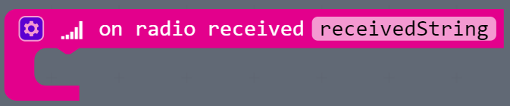

This block is to read the received character string packets. When the packet is received wirelessly, you can use this block.



Send the number 0 wirelessly.



Send the name of variable wirelessly, name is 0.



Send the character string wirelessly.